Homework 1 – Report
CS111 2024 Spring
MUST, C++ programming
- Member name 1: 解汀阳(made by myself) CS111 D2
- Member name 2: None CS111 D1/D2/D3
- Member name 3: None CS111 D1/D2/D3

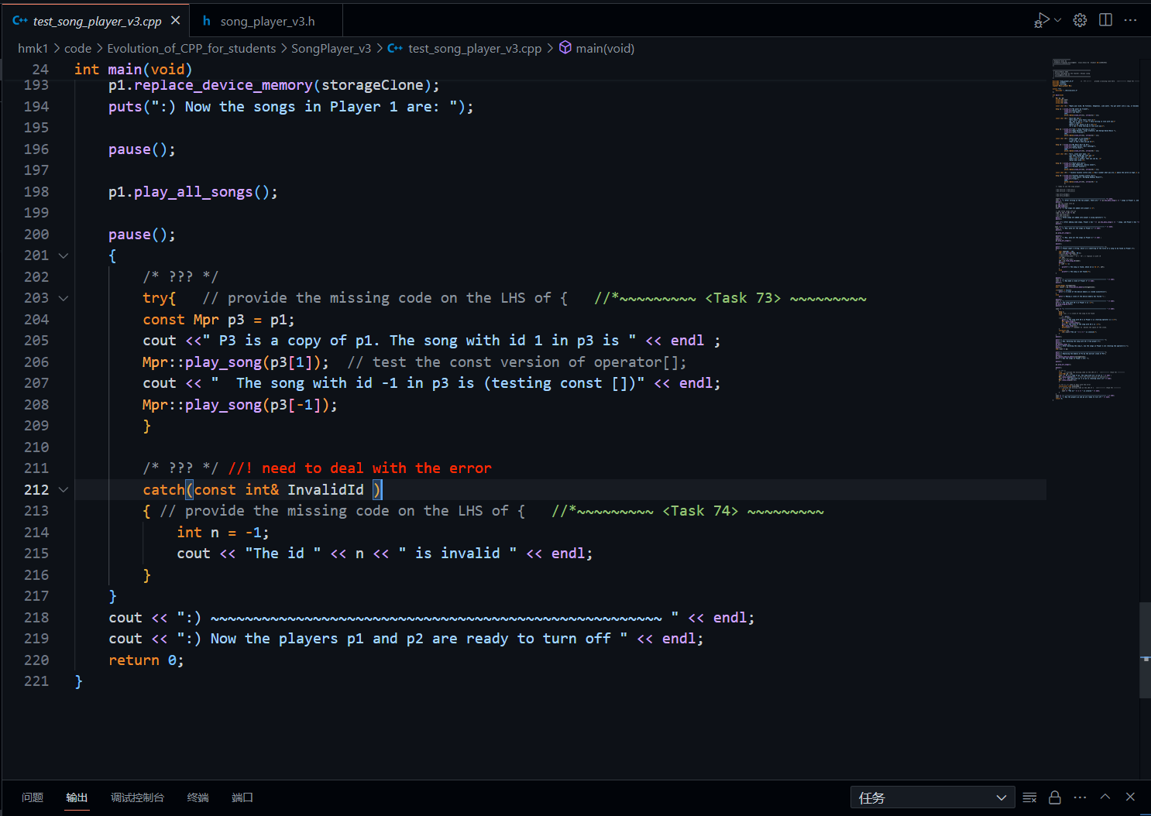
i. Screen capture of code editing

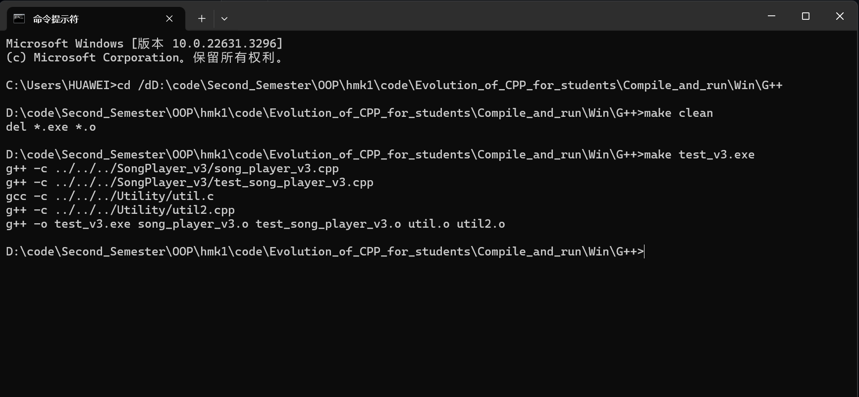
ii. Screen capture of compiling on the terminal

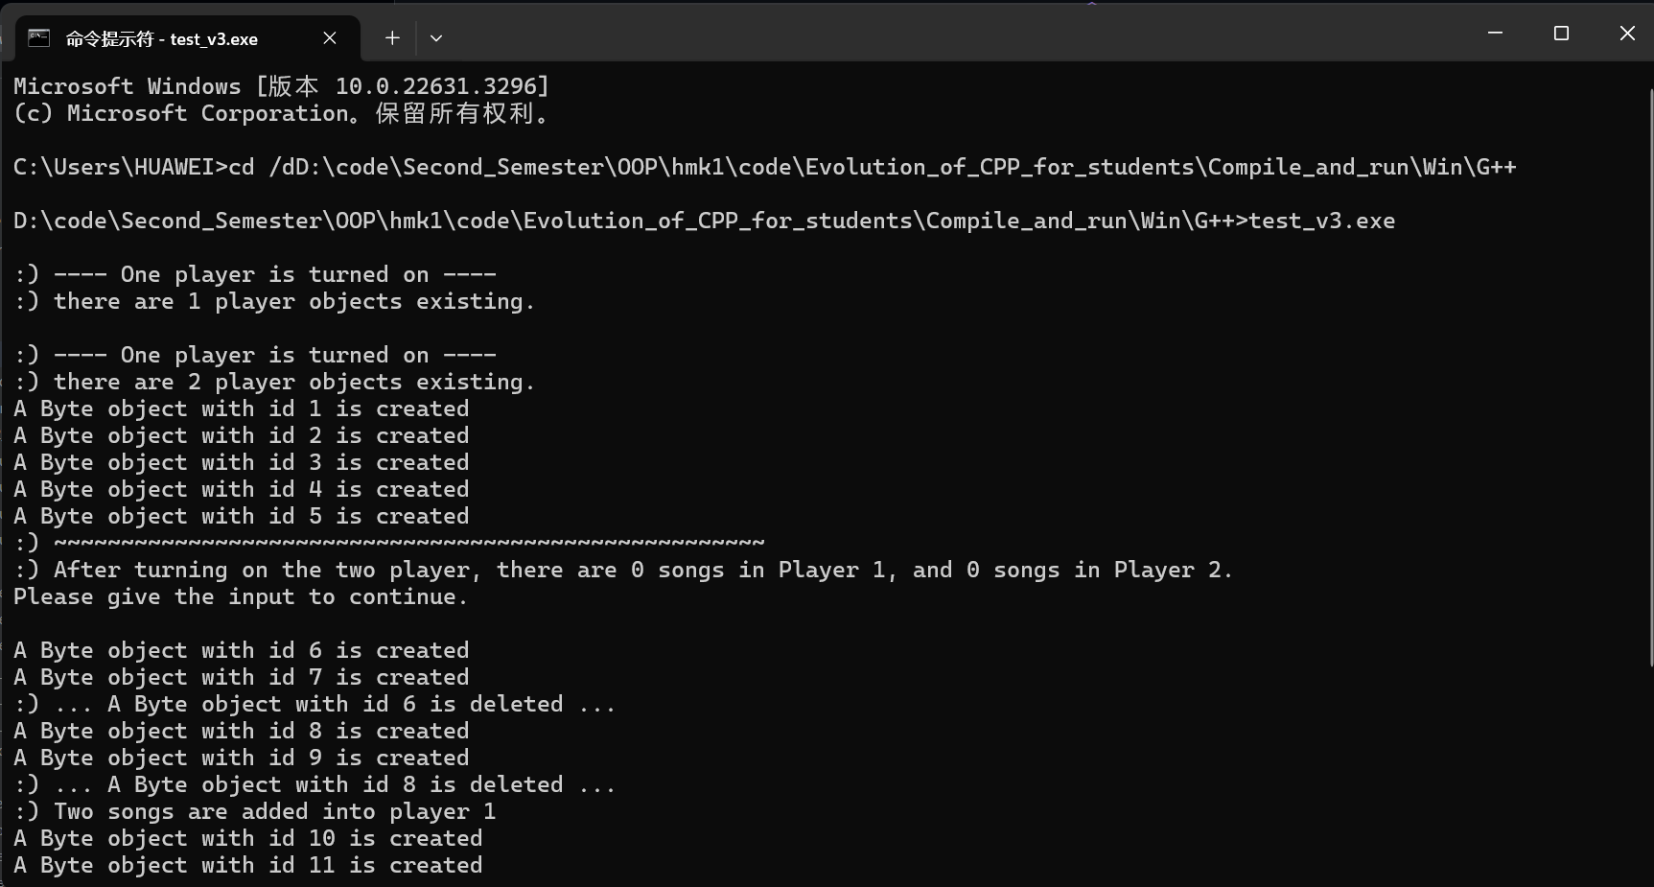
iii. Screen capture of executing the generated executable files.

iv. Summary of the work
I learned the difference between C and C++, realized the advantages of C++ and learned a lot of functions and special features in C++ standard library.

iv.1. The achievements
Learned new features and grammars of C++.

iv.2. The unsolved problems
No unsolved problems. I have asked some questions and confusions to teacher Liang and now it is all solved.

iv.3. The work and contribution of each group member, cooperation of the group
I made this program by myself, so I made all works and contributions.

V. How do you feel about this homework? Is it useful/helpful for you? Other comments?
It is pretty helpful I think. Teacher, you can give some small tasks frequently as well, help us practice everyday and learn some new everyday.

